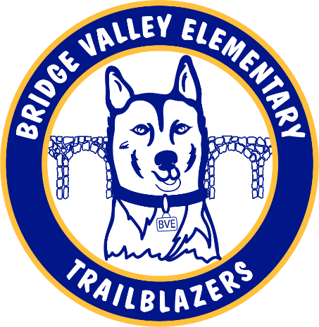

**HSA General Membership Meeting Minutes**

**Wednesday, September 28, 7:00 pm**

HSA Board Member Attendees: Kevin Cochran, David Gittman, Mark Hoff, Jen Hoff, Heather Howard (teams), Victoria Rusay (teams)

Other Attendees (Teams and in-person): Lauren Conway, Robin Danko, Stephanie Dougherty, , Rhiannon Harrington, Jamie Horn, Lauren Munshower, Alissa Nelson, Peter Nelson, Kristina Satterfield, Livia Schloeffel, Maryana Tentler, Jen Wetherbee, Adreinna Wilbourne

1. Mark Hoff called the meeting to order at 7:00 PM
2. Approval of Minutes
3. Motion to approve the 8/28/2022 General Membership Meeting minutes was made by Jen Hoff
   * 1. Stephanie Dougherty seconded the motion
     2. Minutes approved
4. Mr. Cochran provided the Principal's Message
   1. Bridge Valley was recognized as a Microsoft showcase school
   2. He reviewed the MTSS program (Multi-tiered support system)
   3. Support staff (Cafeteria, Bus Drivers, PCA’s, EA’s) levels remain low
   4. Grade level reports
      1. Kindergarten: Nature, Fall season, Letters and Numbers up to 5
      2. First Grade: Friend of the day writing, reading horizons, number bond introduction, addition, and subtraction
      3. Second Grade: Place value, realistic fiction, non-fiction, communities
      4. Third Grade: geography, continents and oceans, pirate day, Johnny apple seed day
      5. Fourth Grade: writing personal narratives, multi-digit addition and subtraction with estimation, What is geography?
      6. Fifth Grade: My View reading journeys, working with whole numbers, Elbow Lane field trip
      7. Sixth Grade: Human body, early humans and rise of civilizations, reading challenges turned into triumphs.
5. Committee Reports provided by Mark Hoff
   1. Yearbook
      1. All open photographer spots have been filled
      2. The cost will be $25
   2. Gardening
      1. Committee is still seeking a co-chair
      2. Kindergarten and Autism Support classrooms will conduct building friends lessons
   3. Fall Fest
      1. Frohleich’s is on for October 15th
      2. Admission will be $20 includes hayride.
      3. Payments can be made through October 13th through My Payments Plus.
   4. Other Committee Notes
      1. Book Fair – week of October 10th
         1. Fall book fair raises money
      2. Teacher Appreciation
         1. Need more help to host on December 12th
      3. Holiday boutique – week of December 5th
      4. New Bingo chairs secured
         1. Event is planned for Friday, February 3rd
      5. Diversity Committee
         1. Planning for large scale event mid-March
      6. Science Alive
         1. 2/27/23 – 3/3/23
         2. Monday 2/27 - Mad Science assembly
         3. Labs will run Tuesday through Friday
      7. Daughter Dance
         1. Date TBD
         2. In need of volunteers
         3. Looking for event to be held on-site at Bridge Valley
6. President’s Report provided by Mark Hoff
   1. Volunteer interest has increased. 40 people expressed interest following B2SN
   2. Apex fundraiser planned 10/10-10/20
7. David Gittman provided the Treasurer’s Report
   1. Not much to report on for July & August
   2. September and August reports being worked on, and an update will be provided at the next meeting.
8. New Business: General Membership Questions/Comments
   1. Activity suggestions from attendee’s included: Bounce House, Movie Night, End of year Talent Show.
   2. Future HSA Meetings are scheduled for:
      1. November 17th 7-8:30 PM (in-person)
      2. February 2, 2023, 7-8:30 PM (in-person)
9. Mark Hoff motioned to adjourn the meeting at 8:02 PM

Next Meeting: Thursday, November 17th, 2022, at 7:00 p.m., in-person at Bridge Valley Elementary School